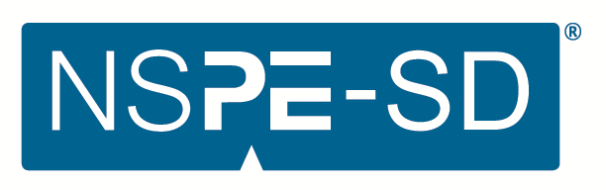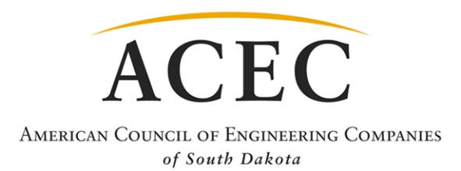

South Dakota Engineering Society and
American Council Of Engineering Companies
of South Dakota

EASTERN CHAPTER

YOUNG ENGINEER OF THE YEAR
METHOD OF SELECTION

This award is established to recognize young members of SDES who have made outstanding contributions to the engineering profession and their communities during the early years of their careers.

Qualifications/Method of Selection: Any licensed professional engineer (P.E. or E.I.T.) who is an SDES member in good standing, whose membership began on or before June 1 of the year prior to the presentation of the award, and who is 34 years of age or younger as of January 1 of the year the award will be presented is eligible for nomination.

State Info (for information only): The individual Chapter award winners will be forwarded to the State level for consideration for the Statewide SDES/ACEC Young Engineer of the Year Award. The Black Hills and Central Chapters may submit one nomination per chapter. The Eastern Chapter may submit up to two nominations.

The Awards Committee will select the recipient based on the following criteria:

- Education and collegiate achievements 10%
- Professional society activities 20%
- Technical society activities 15%
- Civic and humanitarian activities 15%
- Engineering achievement and professional experience 40%

Presentation: The award will be presented during the Eastern Chapter Awards Banquet on February 25th at Great Shots, more details to come.

State Info (for information only): The Statewide SDES/ACEC Young Engineer of the Year Award Recipient will be forwarded to the national level for the national NSPE New Professional Engineer of the Year Award.

If the Statewide SDES/ACEC Young Engineer of the Year Award recipient is employed by an ACEC Member Firm, the Young Engineer of the Year Award recipient has the option of submitting, through ACEC of South Dakota, for the national ACEC Young Professional of the Year Award. Submission for the national ACEC Young Professional of the Year Award is voluntary. If the Statewide SDES/ACEC Young Engineer of the Year Award recipient chooses to do so, the recipient will be responsible for preparing the appropriate forms for the national ACEC Young Professional of the Year Award. For more information, contact ACEC of South Dakota at ACECofSD@gmail.com or visit the ACEC website at http://www.acec.org.

Nomination Format: Nominations must be made on the prescribed form. The form should be typed. Any supporting data should include the name of the nominee with the section letter and title it supports (up to a maximum of 5 pages).

Deadline: Nominations are due at the email address below by January 27, 2023. Nominations emailed after this date will not be considered.

Wes Philips: wphilips@siouxfalls.org

South Dakota Engineering Society and
American Council Of Engineering Companies
of South Dakota

EASTERN CHAPTER

YOUNG ENGINEER OF THE YEAR
AWARD ENTRY FORM

(Please type or print legibly in black ink.)

- Candidate Information
Name of Candidate:
Date of Birth:
Title (indicate if candidate is a P.E.):
Firm/Agency:
Member Firm of ACEC-SD (not required)? Yes: No:
Address:
City State Zip Code
Daytime Phone:
Email Address:
- Attach the following as the basis for nomination of the candidate:

- Education and Collegiate Achievements
Include undergraduate and advanced degrees (give date, major, institution and GPA for each), honorary societies (give society and office held), scholastic awards, organizations (give name of organization and office held) and other activities;

- Professional Society Activities
List offices held, committee assignments and awards at national, state and chapter levels;

- Technical Society Activities
List offices held and committee assignments;

- Civic and Humanitarian Activities
List offices held and committee assignments;

- Engineering Achievements and Professional Experience
Include current position (title, company or institution), dates of employment, description of duties, responsibilities (number of subordinates, annual budget), accountability (position, function, nature of challenge), patents applied for, and awards

- List Addresses of Local Newspapers and Other Publications
(Attach a separate sheet if needed.)

- Send Entries to: (Deadline for submittal is January 27, 2023)
Wes Philips: wphilips@siouxfalls.org
Phone: 605-367-8657

